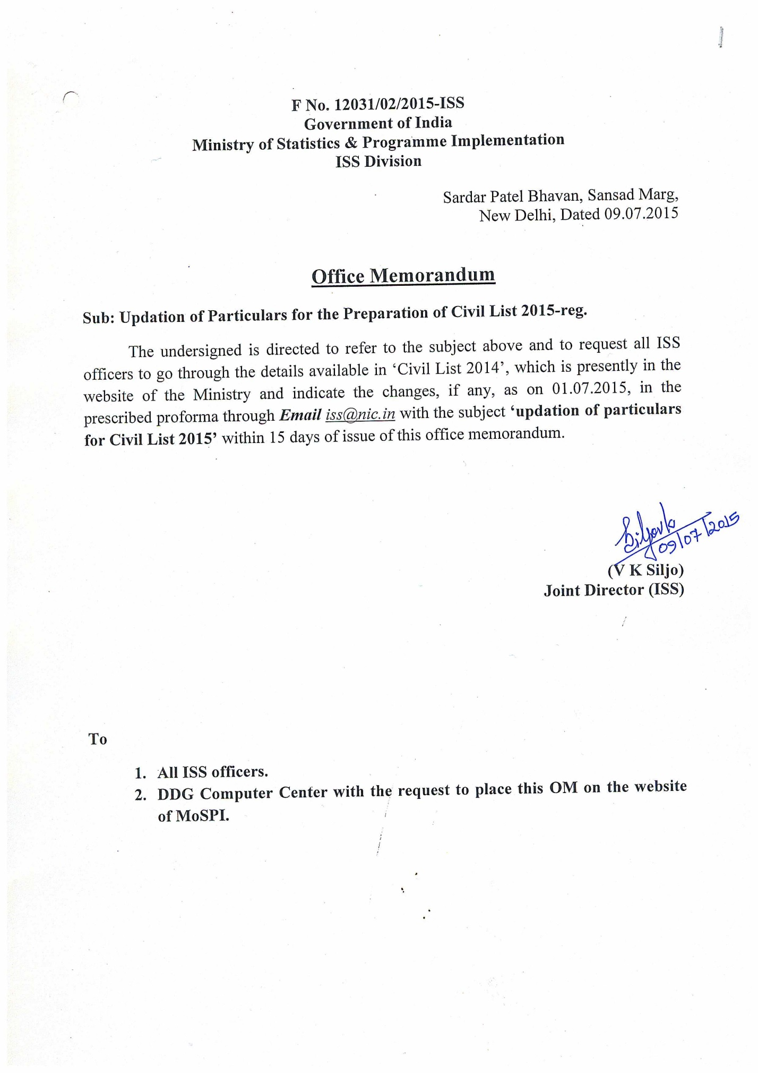
Put (X) in the box if Correction is to be made in the field. W.r.t Civil List 2014 | Sl. No. | Details | Particulars
 | 1 | Name(S/ Sh/Smt/ Ms/Dr.)
 | 2 | Date of Birth
 | 3 | Designation
 | 4 | Grade
 | 5 | Batch
 | 6 | Mode of Recruitment
 | 7 | Date of Joining ISS
 | 8 | Date of Last Promotion  (Regular)
 | 9 | Pay Scale
 | 10 | Grade Pay
 | 11 | Highest Educational Qualification attained
 | 12 | Date of Non Functional Upgradation(NFU) /Parity to | Grade Date  JAG  NFSG  SAG  HAG
 | 13 | Office Address with Room No.
 | 14 | City Name
 | 15 | Pin code
 | 16 | Office Phone No.
 | 17 | Office Fax
 | 18 | Mobile No.
 | 19 | Email Id
 | 20 | Residential address
 | 21 | Pin code
 | 22 | Phone No.
 | 23 | Languages Known
Latest Colour Photograph of the officer.

Photograph in JPEG format.

