HIGHLIGHTS

6. Consumption of Energy Resources

6.1 Consumption of coal and lignite

The estimated total consumption of raw coal by industry has increased from 71.2 MTs during 1970-71 to 586.07 MTs during 2009-10, with a CAGR of 5.4% (Table 6.1). The annual growth rate from 2008-09 to 2009-10 was 6.6%. Consumption of Lignite increased from 3.39 MTs in 1970-71 to 34.42 MTs in 2009-10 registering a compound growth of 5.9%. Consumption of Lignite is highest in Electricity Generation sector, accounting for about 80% of the total lignite consumption.

Industry-wise estimates of consumption of coal (Table 6.4) shows that during 1970-71 railways were the major consumer of coal (15.58 MTs), followed by steel and washery industries (13.53 MTs), electricity generation(13.21 MT) and cement (3.52 MTs). Gradually railways upgraded their technology and reduced the direct consumption of coal, which declined to an estimated 0.27 MT in 1995-96 and to zero afterwards. From the year 1975-76 electricity generation is the biggest consumer of coal, followed by steel industries. Estimated coal consumption for electricity generation increased from 23 MTs during 1975-76 to 411 MTs during 2009-10. Similarly, the estimated consumption of coal by steel & washery increased from 19 MTs to 41 MTs, a two times increase, during the same period.

6.2 Consumption of Crude Oil and Natural Gas

The estimated consumption of crude oil has a secular increase, from 18.38 MTs during 1970-71 to 160 MTs during 2009-10 with CAGR of 5.6%. It decreased from 160.8 MTs in 2008-09 to 160 MTs in 2009-10 (Table 6.1).

The estimated consumption of natural gas has shown a remarkable increase, from 0.7 BCM in 1970-71 to 47.2 BCM in 2009-10, with CAGR of 11.32% over the period(Table 6.1). Industry wise off-take of natural gas shows that natural gas has been used both for Energy (68 %) and Non-energy (32%) purposes(Table 6.8) and the maximum use of Natural Gas is in power generation (45.2%) followed by fertilizers industry (27.9%) and 11.5% natural gas was used for captive use/LPG shrinkage.

6.3 Consumption of Petroleum Products

High speed diesel oil accounted for 37.6% of total consumption of all types of petroleum products in 2009-10. This was followed by LPG (8.8%), Petro (8.6%), Fuel Oil (8.5%) and refinery fuel (7.8%). Consumption of Light Diesel oil continually decreased from 1970-71 (1.1 MTS) to 2008-09 (0.5MTS) (Tables 6.6 & 6.7).

Sector-wise consumption of different petroleum products reveals that transport sector accounts for the lion’s share (59%) of the total consumption of high speed diesel oil. Highest consumption of furnace oil (34.6%) is by industrial sector, whereas ‘Low Sulphur oil’ consumption was also highest (49%) in industrial sector, (Tables 6.6 & 6.7).

6.4 Consumption of Electricity

The estimated electricity consumption increased from 43,724 GWh during 1970-71 to 6,12,645 GWh during 2009-10, showing a CAGR of 6.8%(Table 6.9). The increase in electricity consumption was 10.59% from 2008-09 (5,53,995 GWh) to 2009-10 (6,12,645 GWh). Of the total electricity sales in 2009-10, industry sector accounted for the largest share (39%), followed by domestic (24%), agriculture (20%) and commercial sector (10%). However, it is seen that electricity consumption in domestic sector and agriculture sector has increased at a much faster pace compared to other sectors during 1970-71 to 2009-10, with CAGRs of 9.5% and 8.6% respectively.

Loss of electricity due to transmission has increased from 17.55% during 1970-71 to 32.86% during 2000-01 and declined to 28.86% during 2009-10 (Table 6.10).

6.5 Per- Capita Energy Consumption & Energy Intensity

Per-capita Energy Consumption (PEC) during a year is computed as the ratio of the estimate of total energy consumption during the year to the estimated mid-year population of that year. Energy Intensity is defined as the amount of energy consumed for generating one unit of Gross Domestic Product (At constant prices). PEC and Energy intensity are the most used policy indicators, both at national and international levels. In the absence of data on consumption of non-conventional energy from various sources, particularly in rural areas in the developing countries, including India, these two indicators are generally computed on the basis of consumption of conventional energy.

The estimated PEC has increased from 1204 KWh in 1970-71 to 4646 KWh in 2009-10, a CAGR of 3%(Table 6.2). The annual increase in PEC from 2008-09 to 2009-10 was 11%. The Energy Intensity (at 1999-2000 prices) increased from 0.128 KWh in 1970-71 to 0.165 KWh in 1985-86, but it has again come down to 0.122 KWh(at 2004-05 prices) in 2009-10.
Like in production of energy, for more meaningful comparison in the trends and patterns of growth of consumption of different energy resources, it is desirable to convert all the resources to their energy equivalents by applying appropriate conversion factors and express them in energy units (Joules/peta Joules/ Terra joules). The consumption of energy in peta Joules by primary sources is given in Table 6.3. It is seen that the major source of energy consumed was Electricity accounting for about 53% of the total consumption during 2009-10. Coal and Lignite were second (25%), while Crude Petroleum (17%) was third. The total consumption of energy from conventional sources increased from 36,233 peta joules during 2008-09 to 38823 peta joules during 2009-10, showing an increase of 7.15%.

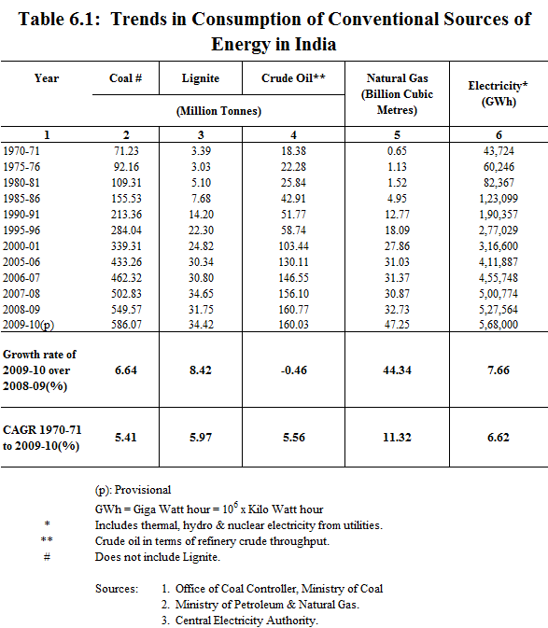

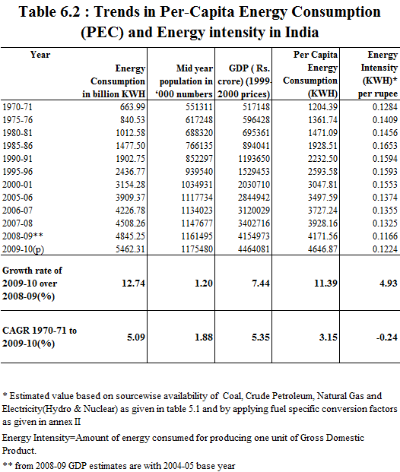

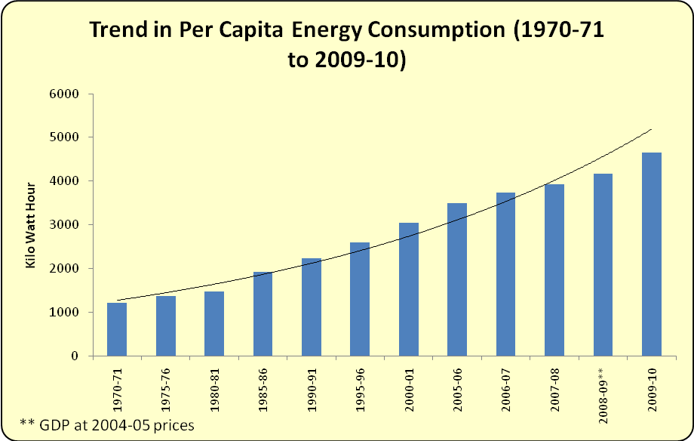

Figure 6.2

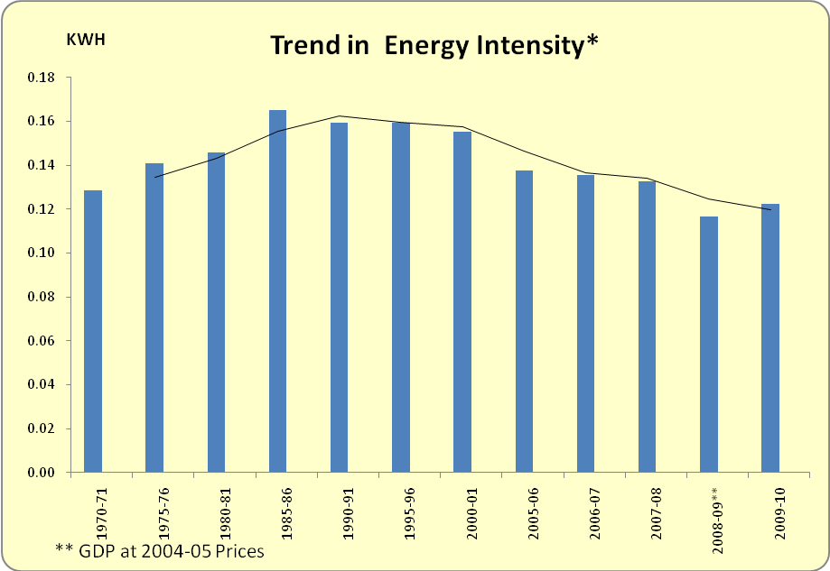

Figure 6.2

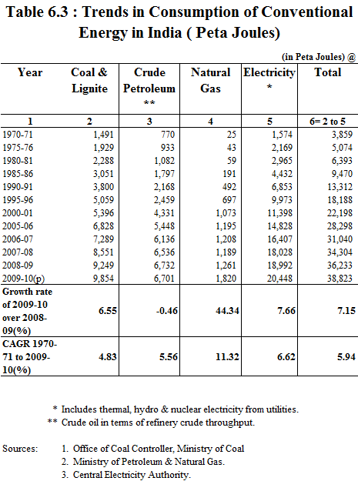

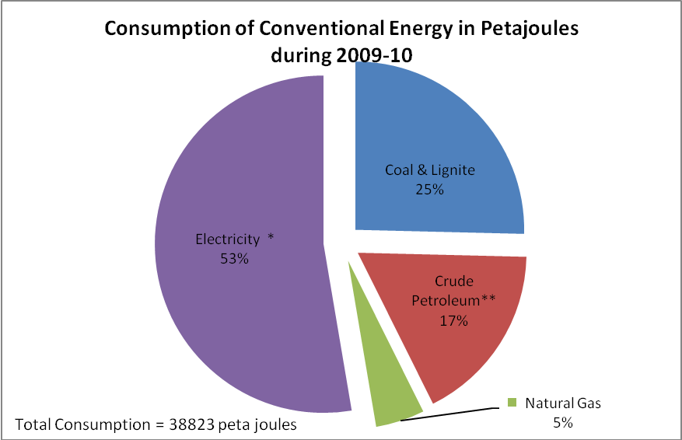

Figure 6.3

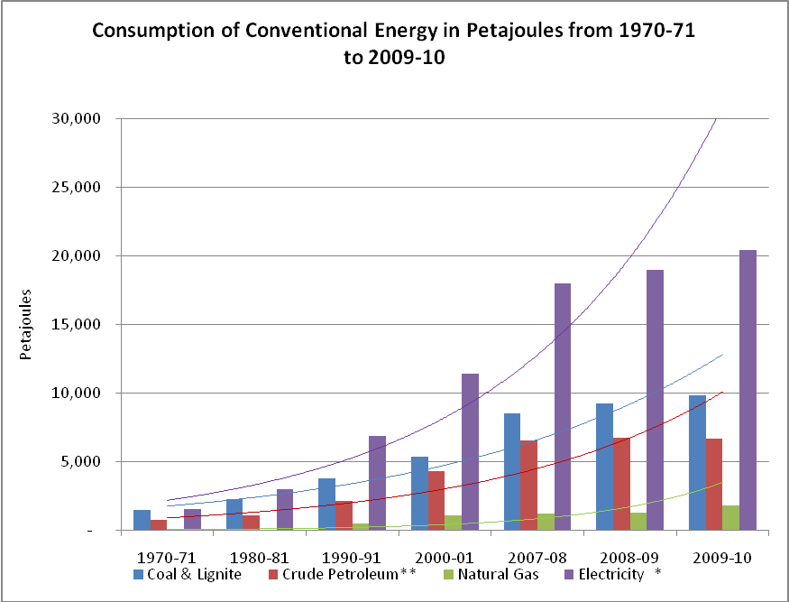
Figure 6.3(A)

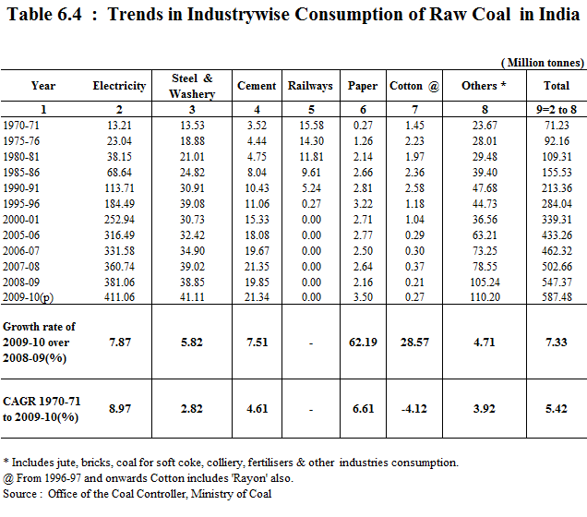

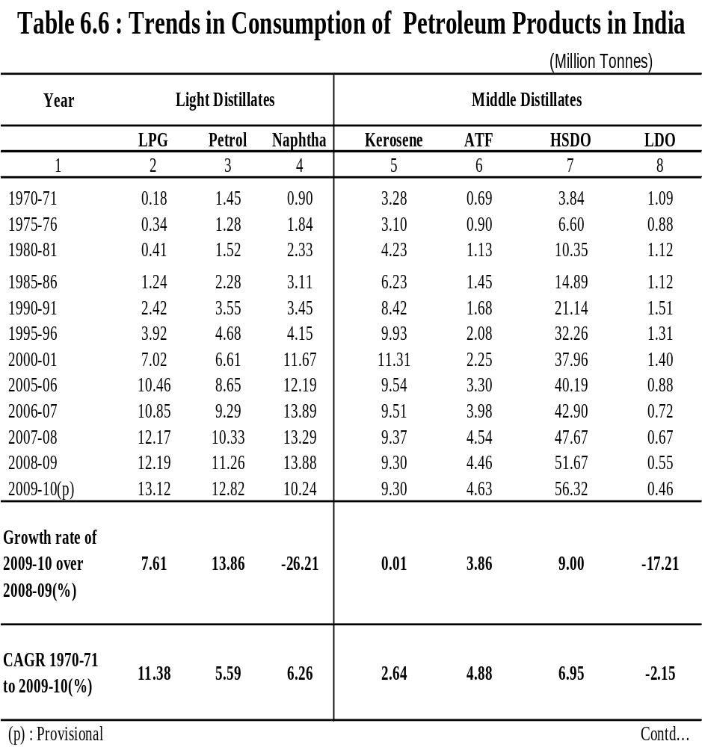

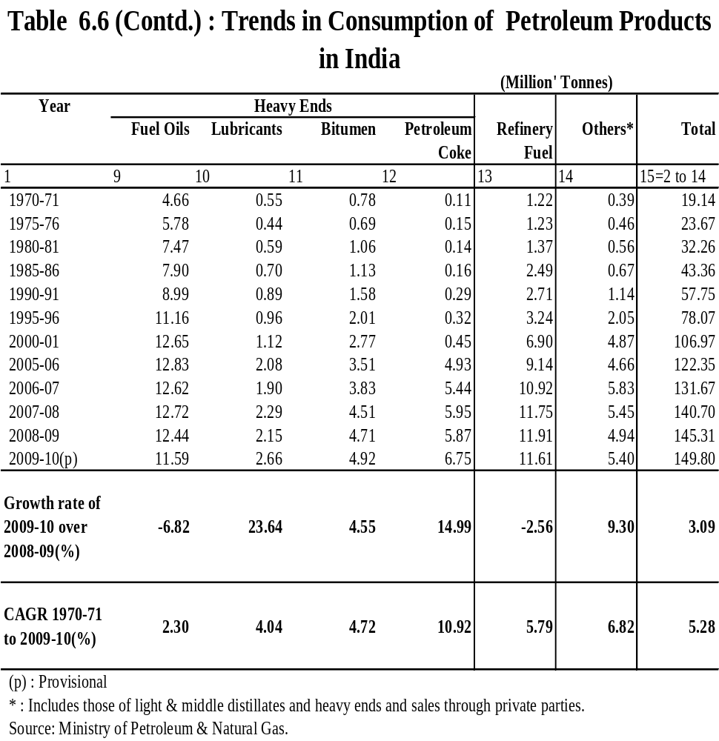

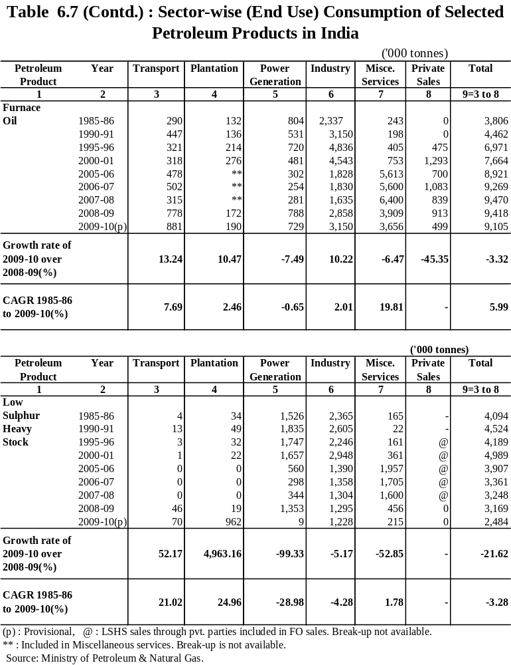

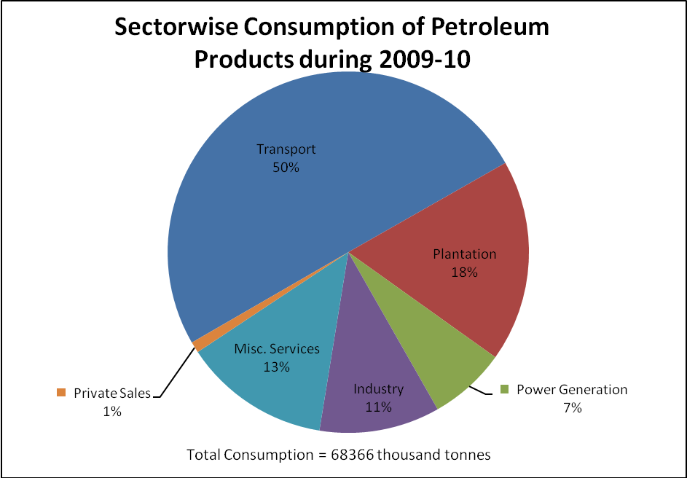

Figure 6.7

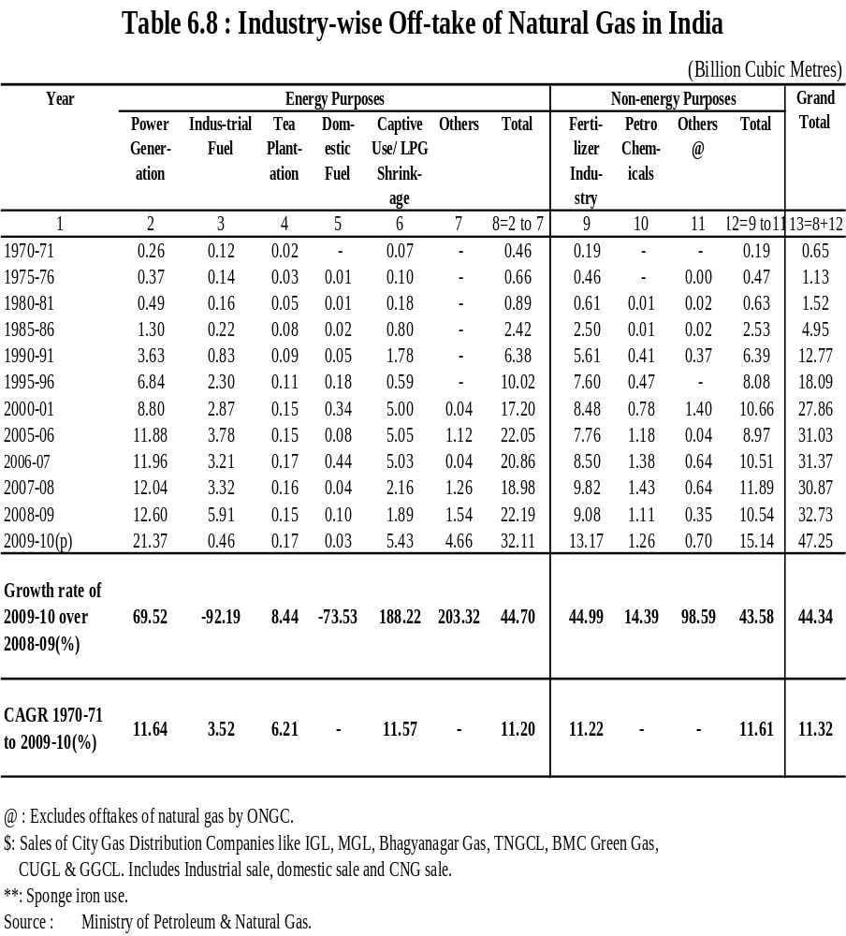

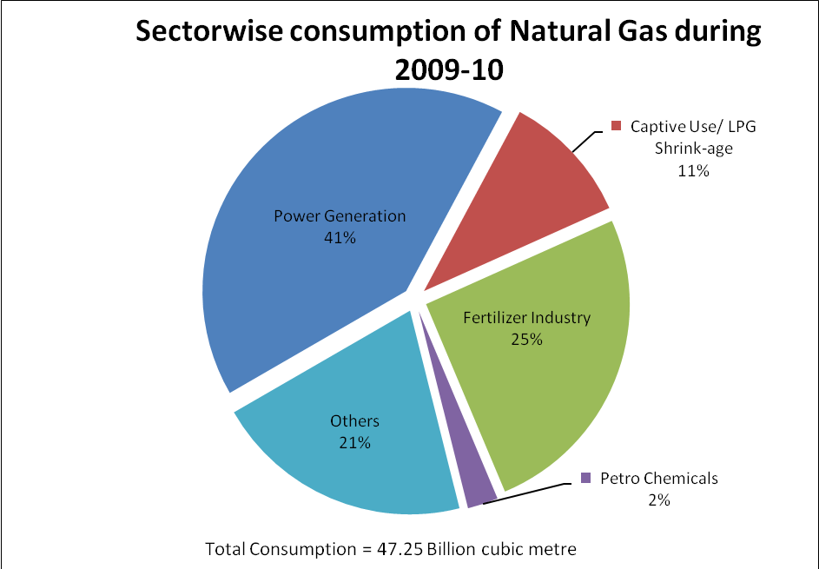
Figure 6.8

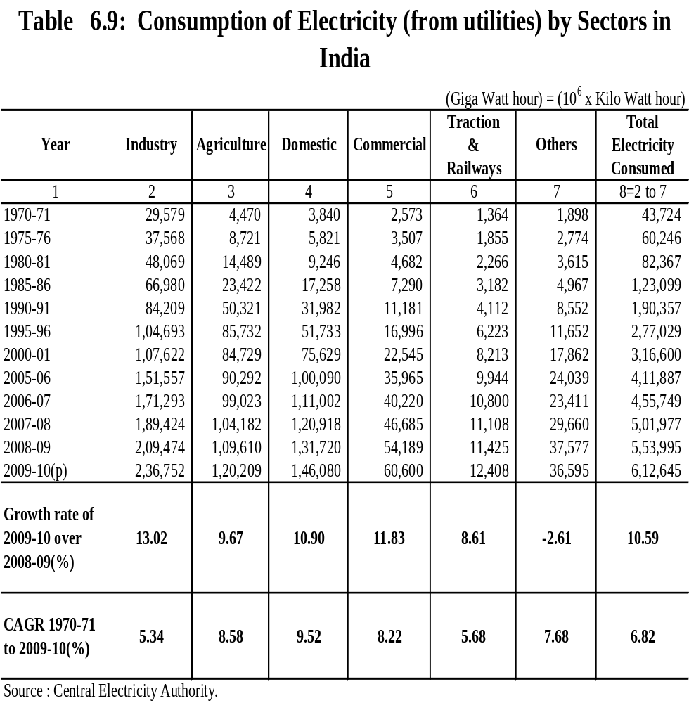

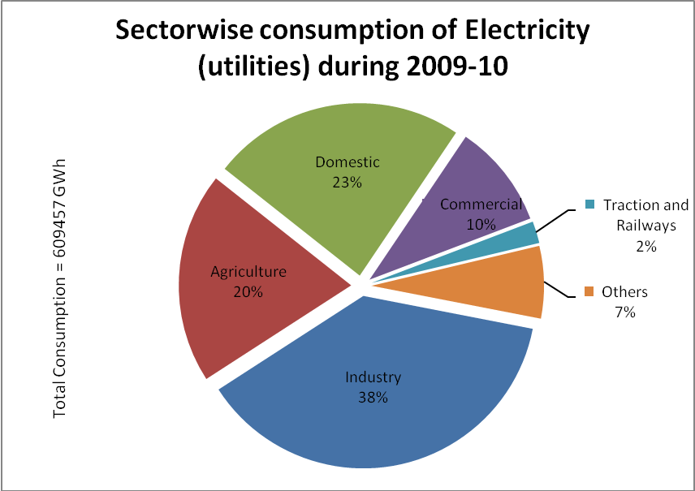

Figure 6.9


